**

GFCI – Ground Fault Circuit Interrupter. An **outlet** that can prevent electrical shock in wet locations. Code requires them today in bathrooms, kitchens, garages and outdoor areas.  Originally required in 1971 only in outdoor areas. Kitchens and baths and garages were added later. If it was built without a GFI required, then it’s grandfathered in unless the owner does something that requires a permit and County/City inspection.

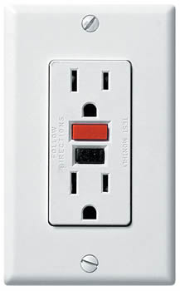

CB – Circuit Breakers. an automatically operated electrical switch designed to protect an electrical **circuit** from damage caused by overcurrent/overload or short **circuit**. Its basic function is to interrupt current flow after Protective relays detect faults condition.

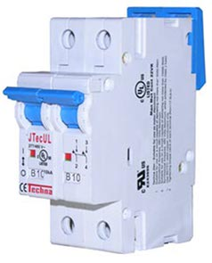

Electrical Panels – a component of an [electricity supply system](https://en.wikipedia.org/wiki/Electrical_service) that divides an electrical power feed into subsidiary [circuits](https://en.wikipedia.org/wiki/Circuit_(electricity)), while providing a protective [fuse](https://en.wikipedia.org/wiki/Fuse_(electrical)) or [circuit breaker](https://en.wikipedia.org/wiki/Circuit_breaker) for each circuit in a common [enclosure](https://en.wikipedia.org/wiki/Enclosure_(electrical)). Enclosure should not have holes for fire protection. AZ requires to be outside, some other states may be in garage or basement.

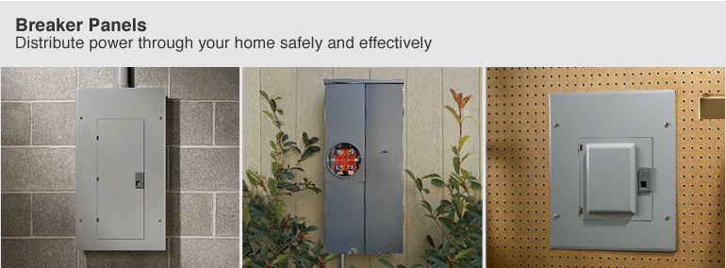 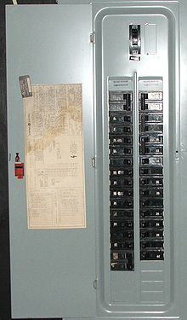

Main panel – newer Main panel – older Sub panel Circuit Breakers

Circuit breakers by code are required to be labeled. Often are not.

Federal Pacific made some panels from 1950-1980 which had problems which could cause local fires. Most inspectors write them up and we have had to replace some for $1500 plus.

Double Tap - one of the most common electrical defects. Two wires into one breaker, breakers are designed for one wire each. Overloads the breaker with 2 circuits instead of one. Often done by landscapers trying to save on installing an additional breaker. Easy fix by adding another breaker or if box is already full, installing a double breaker in place of the single breaker.



Tester – $5-8. Tells whether a socket has all 3 wires correctly installed or not. Hot, neutral & ground. Also the $8 model can test the GFCI by creating a short and tripping it.

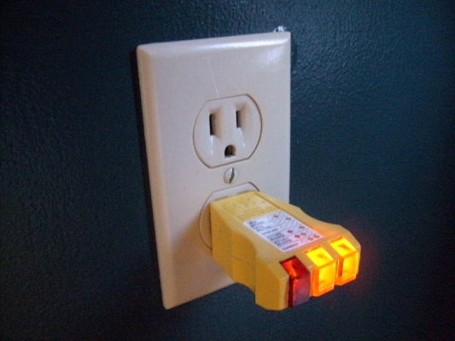

200 AMP Service – the norm for today. Some older homes have 100 Amp service or even less. Often need to be upgraded when adding AC. Determines how much equipment can be run off a panel.

Aluminum wire – Used sometimes in the feeder lines into a circuit panel. Aluminum can oxidize and lessen its ability to carry electricity some, especially around connections. Aluminum wire needs to be coated with a special spray in electrical panels to protect it from oxidation.

