**SOP - Staff and Team Meetings**

**Agenda** – Have a clear written agenda and distribute to attendees in advance so they can prepare. Include time constraints for each item so that discussions don’t get out of hand. Keep the meeting on track with the agenda.

**Mandatory** – Meetings should be mandatory unless out of town or on vacation. Otherwise, busy agents seem to always find a client need to fill during this time and the meetings become useless.

**Honor Attendees Time** – Make it relevant, timely and interesting. Start on time – don’t wait for latecomers. End on time – expect attendees to stay for the complete meeting. Schedule a time for each agenda item and stick to it.

**Staff Meeting** – Weekly on Monday Mornings. Team Lead, Working Agents, Admin Agents

* Calendar – upcoming events and dates
* Feature (Something to learn!) – often a book review, conference review, webinar/seminar review, Keeping Current Matters update (Harney), Buffini update, home items or systems (roofs, plumbing, etc)
* Business – current listings, buyer needs, agent workloads, coming due items
* Marketing – Advertising, website and other ideas and planning, how to use RPR and other tools
* Misc – Quick notes and short updates, a chance to disseminate information to the Team
* Presentations – Modeling and practicing listing and buyer presentations
* SOP of the Week – Review of our Standard Operating Procedures

**Team Meeting** – Monthly on 2nd Thursday. Whole Team including Referral Agents. We often do a brown bag lunch during these meetings. More relaxed atmosphere than the Staff Meetings.

* Calendar – upcoming events and dates
* Feature – We save the more informing items for this meeting, something of interest to all. Book review, conference review, webinar/seminar review, Keeping Current Matters update (Harney), Economic updates, Buffini update, etc
* Business, etc – Anything that we feel will benefit our Referral Agents and keep them up to date on the business. Also, updates to keep them feeling a part of the Team.
* Open Discussion – We end our Team Meetings with 10 minutes of “Open Discussion”, bringing up any subject or question anyone wants to discuss that could improve our business

**SOP – Meetings**

From Book Meetings Suck!

by Cameron Herold

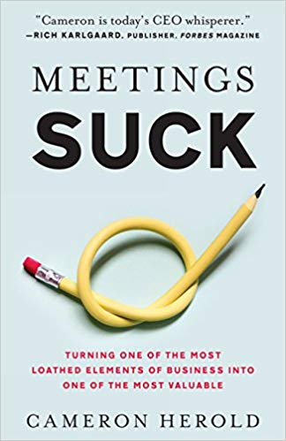

**AGENDA** - Must have a clear agenda distributed to attendees in advance.

* Include how long each item is up for discussion, this helps you realize whether you’ve allocated too much or too little time for certain subjects.
* Include two other key components:
  + Purpose - The purpose of the meeting is one sentence included on the agenda that tells people exactly why they’re asked to attend.
  + Possible outcomes - lay out up to three possible outcomes for the meeting. (I suggest one purpose and three outcomes, because if you attempt to cover more, too many people get invited on too many tangential topics, and time is wasted.)

**STYLE** - Include the meeting style (information sharing, creative discussion, or consensus decision) in the agenda, then you tell your team what to expect and how best to prepare.

* Information sharing meetings involve the sharing of information from the top down, the bottom up, or even laterally. In these formats, there’s no discussion or debate—just the sharing of ideas.
* Creative discussion style involves brainstorming, throwing ideas out, and getting people’s opinions and thoughts. Everyone is invited to participate, although you won’t make decisions using this style.
* Consensus decision is designed for the group to reach a decision. It’s critical that, when the group leaves the room, they’re in agreement that they made the best decision as a team.

**ONE-ON-ONE MEETINGS -** the leader’s role is to provide a balance on three things: direction, development, and support. It is, therefore, important that these meetings be nonnegotiable.

**MISC** - The best thing you can do as the leader is first to hold your ideas back until the end.

Every meeting must include five key roles: the Moderator, the Parking Lot, the Timekeeper, the Participants, and the Closer.