**SOP – Residential Plumbing Systems**

**Plumbing 101:** There are 2 sides of the plumbing systems in a house, 1) the supply side bringing the water in, and 2) the drain side taking the water back out to the sewer or septic tank. Both are separated into the inside pipes and the outside pipes.

**Exterior Supply Lines:**

* Exterior supply line – brings water from the street or well to the house. Main shutoffs are often found near the street in a rectangular box in the ground. The water meter is found in here. The City/County owns the street side of the meter which includes a shutoff, and the homeowner owns from the meter into the house. Exterior supply lines can be any of the materials below. Polybutylene may have been used in the 80’s and 90’s even when it was not used inside the house. There is normally another shutoff valve just before the supply line enters the house.

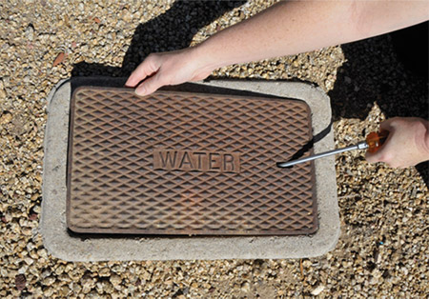 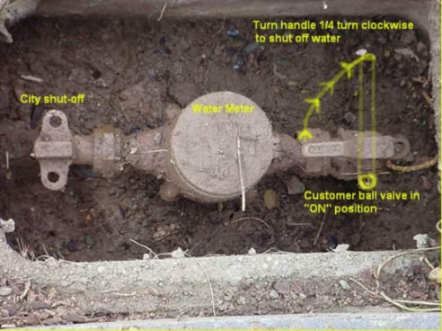

**Interior Supply Lines:**

* Copper – a standard.
* PEX – A plastic called cross-linked polyethylene (PEX). There are no health risks associated with drinking water from PEX pipes. A few types of PEX-pipe may cause prolonged undesirable taste and odor if the water remains in pipes over time. Became prevalent in usage in the mid-90’s. Originally a translucent white, most often now used in red (hot) and blue (cold). Lasts a long time. Commonly used to replace polybutylene.
* Polybutylene – Usage began in the late 70’s. Banned in 1995, but companies could use up remaining supplies. Research suggests that polybutylene pipes are too fragile to withstand common disinfectants (chlorine) found in the public water supply and will become brittle and crack from the inside out. Over time, once enough mini-fractures have formed in the pipe, it will wear out completely and rupture, causing a water leak. Poly pipe is linear molded plastic (the strands all run the same direction) versus cross molded in PEX, which holds the strands together.
* PVC – Polyvinyl Chloride (PVC) is popular for the modern plumbing system pipe, PVC is a white or grey pipe used for high-pressure water, most commonly the main supply line into the house. It isn't as flexible as PEX, making it less appropriate for smaller interior spaces. It resists corrosion and impact damage better than copper pipe because plastic doesn't corrode, and because PVC pipe is thicker than copper pipe. This means it's better for areas where the pipe will be exposed in high-traffic areas.
* Galvanized – Galvanized pipes are steel pipes that have been dipped in a protective zinc coating to prevent corrosion and rust. Galvanized piping was commonly installed in homes built before 1960. ... Today, however, we have learned that decades of exposure to water will cause galvanized pipes to corrode and rust on the inside.
* Black Pipe (not for water plumbing) – A steel pipe used primarily for gas pipes. Not good for water as it is not coated and rusts easily.

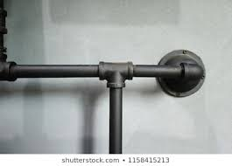

**Interior Drain Lines:**

* PVC –.Polyvinyl Chloride (PVC) or Acrylonitrile Butadiene Styrene (ABS) – Both plastics. Non-toxic and resistant to abrasion. ABS pipes are easier to install compared to PVC pipes, but also more likely to deform when exposed to the sun. PVC are white, ABS are black.

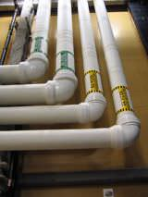 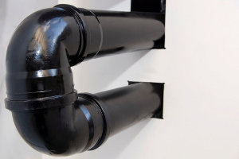

* Iron or Steel – Used in some older homes
* Copper – May be used

**Sewer Lines:**

* The sewer line picks up the wastewater coming out of the house and transports it to the public sewer system. They typically have a cleanout somewhere just outside the house, normally between the house and the street where it connects. Not all main public sewer lines are in the street though, especially if the back is lower than the front of the house. Typically, the homeowner is responsible for the line until the point where it connects to the public sewer. If the system does not have a cleanout, or the cleanout is covered with patios or shrubbery, cleanout access can be attained from a toilet (removing the toilet) or the vent stack pipe on the roof.

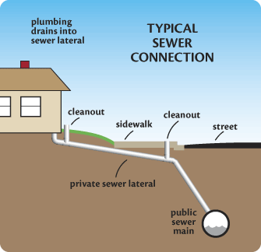

* PVC – Polyvinyl Chloride (PVC) pipes are the most common type of sewer line pipes today. Plastic pipework is lightweight, easy to use, and resilient. When installed properly, PVC pipe is long-lasting and impervious to root penetration.
* ABS – Acrylonitrile Butadiene Styrene is also used.
* Iron & Steel – used mostly in pre-1960’s homes.
* Clay – Vitrified clay pipe (VCP), or [clay tile pipe](https://www.aaa-auger.com/glossary/clay-tile-pipe/), is made from a blend of clay and shale, set at a high temperature to turn the pipe into an inert ceramic. This type of pipe is regularly used in gravity sewer collection mains because it resists most sewage and has a long lifespan. Unfortunately, VCP pipes are the most susceptible to root infiltration. Because clay pipes are joined with hubbed fittings, they do not provide a reliable seal against water. Tree roots are attracted to the water leaking through the joints, and the result is often sewer line damage.

**Septic System:**

* Used where this is no sewer system. Older systems are sometimes grandfathered in once the City or County adds a sewer to the neighborhood, but not always. Pima County requires an “alternate” leach field be designated and approved whenever a new system is installed. If the original leach field fills up and is no long absorbent, then the homeowner is required to install the alternate field and abandon the old one. This can be expensive ($5-15K). USDA says a leach field should last 20 years. We see much longer – depends upon the number of users in the household and how the system is cared for. Many say it should be pumped every 3-5 years and users should be careful what they put down the drain. And be careful with landscaping over the system and move surface water away from the field.
* Many installers say do not use the bacteria solutions that are suggested to be flushed down the drain monthly. The system should take care of itself.

