Key Points – For Brokers/Mangers 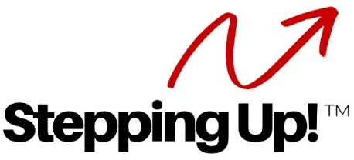

- What is it?
  - A unique business model that reaches out to Retiring Agents offering continued income
  - Retaining Company Dollars

- Success Record
- Our Stats:
  - Over $100M additional sales kept with LRC; Over 400 transactions and fees!
  - Over $750K commissions paid to our Referral Agents at 25%!
- Our Top Referral Agent: 9 years running:
  - Over $500K personal gross income
  - Had an offer for only $14K for her business!
- Often, Referral Agents’ first year with us are significantly higher sales than their previous year on their own due to synergy, excitement and marketing

- Currently
  - In 7 Long Realty Offices (Foothills, Oro Valley, Tanque Verde, Central, Golder Ranch, Sierra Vista, Green Valley)
  - Expanding now to Phoenix and the nation
  - We work with managers to select the right Team Lead
  - One team per office

- Offering
  - Proven strategies – 9+ years!
  - Coaching and mentoring for Team Leads
  - Manual and forms, procedures and presentations
  - Infrastructure and training to handle the expanded volume
  - Monthly Stepping Up! Innovation Group (coaching) – great synergies!

- Perfect solution
  - Keep Brokerage revenue
  - Keep retiring agents active
  - Keep their sphere active
  - Keep their clients with your Brokerage

