Agreement Add-Ons
Additions to Agreements
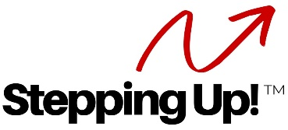

Business Mixer Group (if you have one)

- Business Mixer Group: Should you refer a business to our Business Mixer Group and that business refers a customer back to the Team, that customer will become your client at the normal 25% commission rate. Team Lead has final approval/disapproval of membership in the Business Mixer Group. We encourage all Team agents to use these businesses for referrals as much as possible (Team players benefit us all).

Transitioning Agent Plan (Transition to an RA over a couple year period)
Add language at top of Agreement

Transitioning Agents:
- Year 1 – 25% fee to team of all their business. 50/50 split on LRC threshold.
- Look closely at marketing costs versus last year’s revenue first.
- 75% to team of only those deals the team works? 50% if both work it (ie – out of town or not working for part of transaction).
- Year 2 – 50% fee to team of all their business. 75% to team of deals the team works. OR, may consider 25% still to team of transactions they work if at least 50% of their transactions are worked by the team at 75% for the team.
- Year 3 – must become a referral agent 100%.
- Look at expenses for new RAs and tell them what the team will absorb.

