SOP – Flat Roofs 101 
1/31/2022

Here’s an example of a flat roof build up. The top layer is white elastomeric coating to reflect the sun and keep it off the black ply sheets. The next 3 layers are ply sheets with hot tar mopped in between them, this is your main seal. Then the bottom layer is the actual deck surface, the plywood decking. In Arizona, we don’t normally see the rigid roof insulation and asphalt applied on top of it that you see below. Our insulation is normally below the roof decking (plywood sheathing) between the interior ceiling and the exterior roof decking.

We do see foam layers applied sometimes on top of the ply sheets, but that’s a totally different story and there are few roofers that will work with foam roofs.

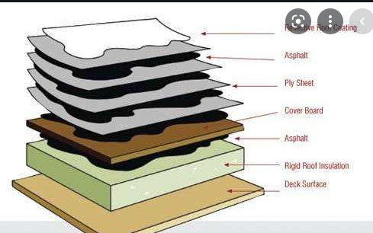

Click here to watch our 8 minute You Tube video on Flat Roofs.

https://youtu.be/CB9MtOGBliQ

